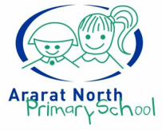

**CURRICULUM FRAMEWORK**

**Help for non-English speakers**

If you need help to understand the information in this policy please contact the Ararat North Primary School Office: Ph: 03 53 52 3766.

**Purpose**

The purpose of this framework is to outline Ararat North Primary School’s organisation, implementation and review of curriculum and teaching practices and to ensure that, taken as a whole, all eight learning areas are substantially addressed, unless an exemption applies.

The framework shows, at a high level, how the school will deliver its curriculum, how the curriculum and teaching practice will be reviewed, how we assess student learning, how we record and monitor student performance, and when and how we report to parents.

This curriculum framework should be read alongside our whole school, curriculum area, year level and unit / lesson curriculum plans.

**overview**

Ararat North Primary School provides all students with a planned and structured curriculum to equip them with the knowledge, skills and attributes needed to complete their schooling and to make a successful transition from school to work, training, or further education.

Ararat North Primary School is committed to offering a comprehensive curriculum based on the [Victorian Curriculum F-10](https://victoriancurriculum.vcaa.vic.edu.au/). The key points in this framework, and in line with the [F–10 Revised Curriculum Planning and Reporting Guidelines](https://www.vcaa.vic.edu.au/Documents/viccurric/RevisedF-10CurriculumPlanningReportingGuidelines.pdf), are a commitment to:

* A defined curriculum content is the basis for student learning
* Curriculum planning that is based on two-year bands of schooling rather than each year level
* Developing and publishing a separate whole-school curriculum plan that documents our teaching and learning program
* Reporting student learning against the achievement standards in the curriculum
* Reporting student learning to students and parents in line with the Department’s [Reporting Student Achievement and Progress Foundation to 10](https://www2.education.vic.gov.au/pal/reporting-student-achievement/policy) policy.
* Complying with Departmental policies relating to curriculum provision, including:
  + [Physical and Sport Education — Delivery Outcomes](https://www2.education.vic.gov.au/pal/physical-and-sport-education-delivery-requirements/policy)
  + [Sexuality and Consent Education](https://www2.education.vic.gov.au/pal/sexuality-education/policy)
  + [Holocaust Education – Delivery Requirements](https://www2.education.vic.gov.au/pal/holocaust-education-delivery-requirements/policy)

Ararat North Primary School is committed to lifelong learning by providing an inclusive, safe and happy community in which diversity is valued and celebrated. Our curriculum and culture of caring creates a positive learning environment that engages and challenges students to achieve personal success and make constructive contributions to society. Our school encourages students to strive for doing their best in all endeavours.  At Ararat North Primary School our curriculum presents students with the opportunity to develop strong understandings of a range of concepts throughout their school lives. Our broad curriculum is planned and taught sequentially and allows students to have some ownership in all aspects of their learning. It is designed to develop thinking and social skills, foster engagement with the wider community and include use of technology to assist in student learning. To support the delivery of the curriculum at our school we access and select a wide range of suitable educational resources, set homework that enhances classroom learning and undertake a range of student assessment and reporting activities.

**Implementation**

* The Principal has the overall responsibility for the implementation of curriculum at our school.
* Our school will recognise and respond to diverse student needs when developing its curriculum programs and curriculum plan.
* The Victorian Curriculum will be used as a framework for curriculum development and delivery at Foundation to Year 6 in accordance with DET policy and Victorian Curriculum and Assessment Authority (VCAA) guidelines.
* The school implements the Framework for Improving Student Outcomes (FISO) model for continuous school improvement.
* In developing the Curriculum Plan, our school will provide at least 25 hours of student instruction per week and operate on a weekly timetable.Each day will be divided into three learning blocks of 120 minutes, 90 minutes and 90 minutes.
* The school will support the Victorian Curriculum with other programs according to priorities e.g. Sustainability, First Nations curriculum
* Teaching and learning programs will be resourced through Program Budgets.
* Our school will identify and cater for the different needs of particular cohorts of students when developing its curriculum plan using the Response to Intervention model
* An agreed Assessment Schedule will be implemented by teachers to guide Teaching and Learning for individual and groups of students and for program development.
* The school will ensure English as an Additional Language (EAL) is provided for new arrivals.
* The school will provide quality and meaningful education for Koorie students by use of the Marrung: Aboriginal Education Plan 2016-2026.
* Our school will ensure all students have access to a quality education that meets their diverse needs. This will be reflected in Individual Education Plans, intervention programming and best use of Education Support resources.
* Our school will provide culturally appropriate and inclusive programs for all students by creating an environment that respects, recognises and celebrates cultural identity through practice and curriculum.
* The Principal in consultation with all teachers will determine the curriculum program for the following year, based on student need determined through data analysis and the School Strategic and Annual Implementation Plans.
* The DoE requirements related to the teaching of Health, Physical Education, Resilience Rights Respectful Relations and LOTE will be implemented.
* Our school will provide specialist classes in the areas of Science, Health and Physical Education and Visual Art.
* The use of Information and Communications Technology (ICT) will be integrated across the curriculum to support the improvement of teaching and learning outcomes.
* In developing its curriculum plan the school will provide a broad range of educational pathways to ensure improved student outcomes.
* The school will document through its School Strategic Plan and the Annual Implementation Plan which key strategies for improvement in student learning outcomes form part of its curriculum plan.
* Curriculum will be reviewed annually according to the school’s priorities.
* A wide range of educational resources to support teaching and learning will be accessed.
* The school will undertake a range of student assessment and reporting activities.
* The school will ensure that classrooms are safe and classroom activities are conducted safely.

**Time Allocations per Learning Area**

|  |  |
| --- | --- |
| **Years F-2** | |
| **Curriculum Area** | **Minutes per week** |
| English | 750 |
| Mathematics | 300 |
| Integrated Studies – Science, Humanities, Technology and Language | 250 |
| Health and Physical Education | 100 |
| The Arts | 100 |

|  |  |
| --- | --- |
| **Years 3-6** | |
| **Curriculum Area** | **Minutes per week** |
| English | 750 |
| Mathematics | 300 |
| Integrated Studies - Science, Humanities, Technology and Language | 200 |
| Health and Physical Education | 150 |
| The Arts | 100 |

|  |  |  |  |
| --- | --- | --- | --- |
| **Additional school programs that operate within this structure:** | | | |
| Assembly | Buddies | Excursions | MATES |
| Intervention | Library | Incursions | DASH |

**Language provision**

Ararat North Primary School will deliver a second Language (Language Other Than English), based on available teacher resourcing. The school is currently moving from French to a first nations language and once this transition is complete, this policy will be updated accordingly.

**Pedagogy**

Teachers at our school utilise the Victorian Teaching and Learning Model (VTLM). The VTLM consists of four components:

A vision for learning helps create a unified set of values and beliefs to drive a high performance learning culture.

The practice principles for excellence in teaching and learning (practice principles) are nine signature pedagogies which make the difference in improving student achievement and motivation.

The pedagogical model describes what effective teaching looks like in the classroom and helps teachers apply the practice principles. Teachers may elect to use a suitable pedagogical model such as GANAG or the 5 Es (described below).

The high impact teaching strategies (HITS) are ten instructional practices that reliably increase student learning wherever they are applied.

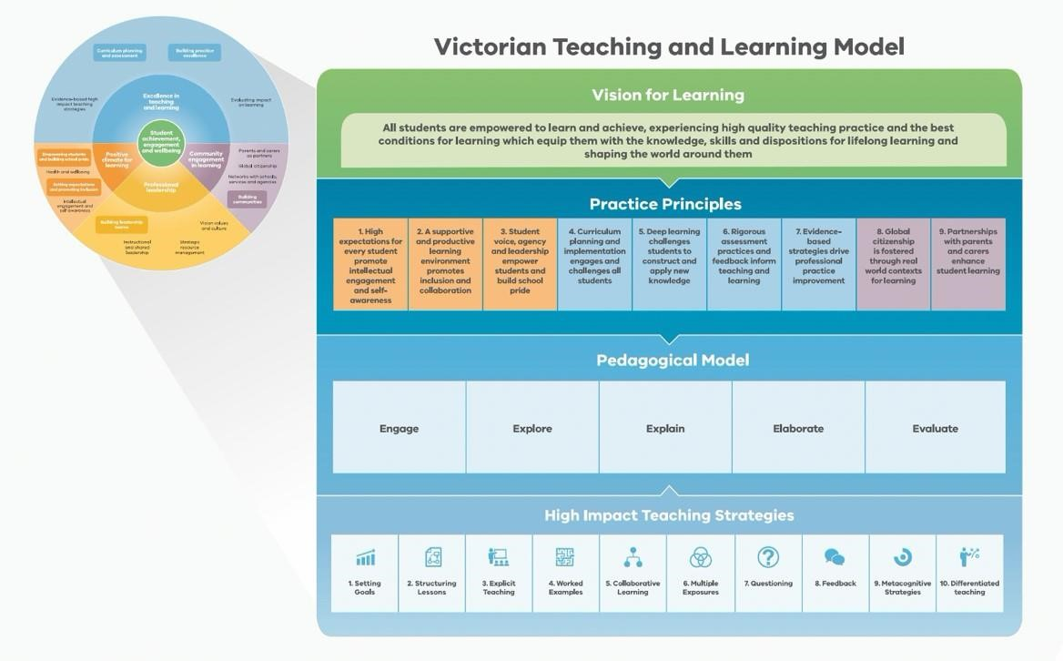

**Assessment**

Ararat North Primary School assesses student progress in line with the Department’s [Assessment of Student Achievement and Progress Foundation to 10](https://www2.education.vic.gov.au/pal/assessment-student-achievement/policy) policy.

Students at Ararat North Primary School will have multiple and varied opportunities to demonstrate learning and achievement. Teachers use assessment tasks that cover multiple curriculum levels to ensure that evidence of learning and growth is captured for every student.

* Teachers at Ararat North Primary School use a combination of formative assessment for learning (to focus feedback and guide future learning) and summative assessment of learning (to determine what the student has learned at the end of a sequence of learning), alongside student self-assessment and reflection.
* Assessment is used in an ongoing way, to guide future lessons and learning, as well as to keep students and parents informed of student progress.
* Teachers will use a variety of assessment strategies to gather evidence about student achievement. The agreed assessment processes and tasks are documented in the Subject Unit Designs and Learning Sequences. The assessments may include, but are not limited to, tests and assignments, projects, portfolios, performances, discussions or student-teacher conferences.
* Assessment tasks are developed to support students to show their knowledge, skills and understandings and will include clear instructions, relevant supporting documents (scaffolds, planning documents, etc) and allow sufficient time for completion. Teachers will make modifications to the task to cater for students with additional learning needs.
* Ararat North Primary School will develop Individual Education Plans (IEPs) for students who are part of the Disability Inclusion program(DI), Koorie students and students in ‘Out of Home’ care, in consultation with students, parents and where appropriate, with outside agencies.
* Teachers will assess the achievements of students with disabilities and impairments in the context of the Victorian Curriculum and the ‘Towards Foundation Level Victorian Curriculum’ where applicable.
* The English language proficiency of English as Additional Language EAL students will be assessed using the Victorian Curriculum F-10 EAL.
* Where possible, staff will participate in cross marking of assessment tasks (moderation) involving assessment rubrics and work samples so that staff can apply consistent judgements of student progress against Victorian Curriculum Standards across the school.

**Reporting**

Ararat North Primary School reports student progress to parents in line with the Department’s [Reporting Student Achievement and Progress Foundation to 10](https://www2.education.vic.gov.au/pal/reporting-student-achievement/policy) policy. In addition, Ararat North Primary School ensures that there is continuous sharing of assessment information formally and informally with parents/carers throughout the term/semester, including through twice-annual formal reporting.

At Ararat North Primary School formal reports will be in a written format easy for parents/carers to understand and will be accessible in digital form with the option to translate text from English to another language, to cater to our school community.

* Ararat North Primary School  will report directly against the Victorian [Curriculum F-10 achievement standards](https://www.vcaa.vic.edu.au/curriculum/foundation-10/Pages/default.aspx?Redirect=2)or, if reporting on students for whom English is an additional language, the Victorian [Curriculum F-10 EAL achievement standards](https://victoriancurriculum.vcaa.vic.edu.au/english/english-as-an-additional-language-eal/introduction/rationale-and-aims).
* Both student achievement and progress will be included in the report.
* An age-related five-point scale, where the quality of a student’s achievement against what is ‘expected’ for students of that year level at the time of reporting, will be used for reporting against the achievement standards in English, Mathematics and Science (where applicable) and in other subjects at the discretion of teaching staff.
* Opportunities will be provided for parents/carers and students to discuss the school report with teachers and/or school leaders.

Parent-teacher interviews, conducted twice-yearly, enable the opportunity to discuss the students’ progress and how they can continue to be supported at home. Interpreting services will be made available where required.

**curriculum and teaching practice review**

School curriculum and teaching practice is reviewed against the [Framework for Improving of Student Outcomes (FISO 2.0)](https://www2.education.vic.gov.au/pal/fiso/policy). FISO and the FISO improvement cycle help identify focus areas for improvement and to evaluate the impact of introduced initiatives.

**Review of school curriculum**

All teaching and leadership staff will meet regularly (at least once per term) to track whole school data and identify potential curriculum areas that require focus. Data analysed may include, but is not limited to, NAPLAN, Progressive Achievement Tests (PAT), Cold Write, Essential Assessment, school based testing and teacher judgments based on learning outcomes in the Victorian Curriculum.

 Student learning outcomes data will be reported in the Annual Report to the School Community provided to the DET, and is also available on the State Register maintained by the Victorian Registration and Qualifications Authority.

**Review of teaching practice**

Ararat North Primary School reviews teaching practice via:

* Professional Learning Communities, which link the learning needs of students with the professional learning and practice of teachers and provide an opportunity for teachers to collaboratively evaluate the effect of high impact teaching strategies; and
* the Performance Development cycle, which provides an opportunity to provide feedback to teaching staff on their performance to support ongoing learning and development, with a focus on how student learning can be improved through improving teaching practice.

**Further information and resources**

* Policy and Advisory Library:
  + [Curriculum Programs Foundation to 10](https://www2.education.vic.gov.au/pal/curriculum-programs/policy)
  + [Framework for Improving Student Outcomes (FISO 2.0)](https://www2.education.vic.gov.au/pal/fiso/policy)

* + [Assessment of Student Achievement and Progress Foundation to 10](https://www2.education.vic.gov.au/pal/assessment-student-achievement/policy)
  + [Digital Learning in Schools](https://www2.education.vic.gov.au/pal/digital-learning/policy)
  + [Students with Disability](https://www2.education.vic.gov.au/pal/students-disability/policy)
  + [Koorie Education](https://www2.education.vic.gov.au/pal/koorie-education/policy)
  + [Languages Education](https://www2.education.vic.gov.au/pal/languages-education/policy)
  + [Physical and Sport Education — Delivery Requirements](https://www2.education.vic.gov.au/pal/physical-and-sport-education-delivery-requirements/policy)
  + [Holocaust Education](https://www2.education.vic.gov.au/pal/holocaust-education-delivery-requirements/policy)
  + [Reporting Student Achievement and Progress Foundation to 10](https://www2.education.vic.gov.au/pal/reporting-student-achievement/policy)
  + [Sexuality and Consent Education](https://www2.education.vic.gov.au/pal/sexuality-education/policy)
  + [School Hours (including variation to hours)](https://www2.education.vic.gov.au/pal/school-hours/policy)

**POLICY REVIEW AND APPROVAL**

|  |  |
| --- | --- |
| Policy last reviewed | May 2023 |
| Approved by | Principal |
| Next scheduled review date | May 2026 |